Problem Statement:

Since a normal image is not clear and it may not show some useful information or its brightness level seems inappropriate, then to get rid of such problems, we perform histogram equaluzation to get a better and clearer image.

Block Diagram:

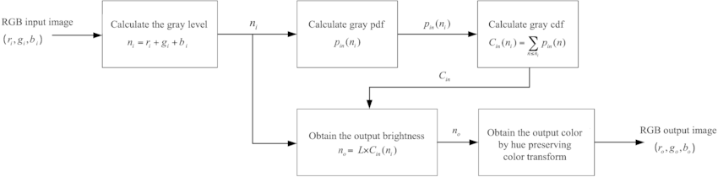

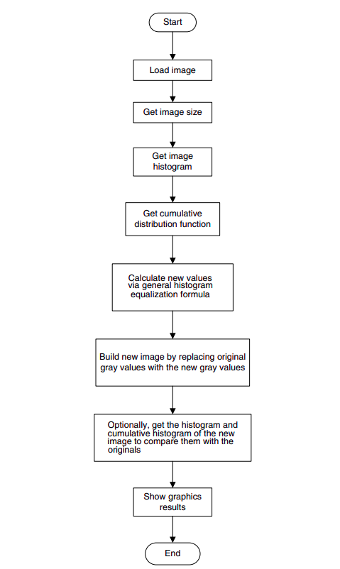
In this section the general approach for cumulative histogram equalization is described. Here are the steps for implementing this algorithm. 1. Create the histogram for the image. 2. Calculate the cumulative distribution function histogram. 3. Calculate the new values through the general histogram equalization formula. 4. Assign new values for each gray value in the image.

Module Description:

Histogram equalization is a simple technique to enhance a digital image. It is a standard tool in digital image processing and computer vision applications. It is especially effective in improving the visual quality of grayscale images.For example, histogram equalization has been applied extensively in medical imaging to improve the contrast of X-ray and MRI images. Such improvement enables more accurate medical diagnosis.

Software & Hardware Used:
The cumulative histogram equalization was implemented and tested using MATLAB, Numpy and PIL(Python Image Library)

Code:

Implementation of histogram equalization for grayscale image:

import numpy as np
from PIL import Image
import matplotlib.pyplot as plt

Read image file and convert to numpy array
img_filename = 'Unequalized_Image.jpg'
save_filename = 'Equalized_Image.jpg'
img =Image.open(img_filename)
imgray = img.convert(mode='L')
img_array = np.asarray(imgray)

Calculate normalized histogram and cumulative histogram

histogram_array = np.bincount(img_array.flatten(), minlength=256)
num_pixels = np.sum(histogram_array)
histogram_array = histogram_array/num_pixels
chistogram_array = np.cumsum(histogram_array)

Calculate pixel intensity transformation map

transform_map = np.floor(255 * chistogram_array).astype(np.uint8)

Equalization by pixel transformation

img_list = list(img_array.flatten())
eq_img_list = [transform_map[p] for p in img_list]
eq_img_array = np.reshape(np.asarray(eq_img_list), img_array.shape)

Calculate histogram and cumulative histogram of equalized image

ori_cdf = chistogram_array
ori_pdf = histogram_array

eq_histogram_array = np.bincount(eq_img_array.flatten(), minlength=256)
num_pixels = np.sum(eq_histogram_array)
eq_pdf = eq_histogram_array/num_pixels
eq_cdf = np.cumsum(eq_pdf)

plt.figure()
plt.plot(ori_pdf)
plt.plot(eq_pdf)
plt.xlabel('Pixel intensity')
plt.ylabel('Distribution')
plt.legend(['Original','Equalized'])
plt.figure()
plt.plot(ori_cdf)
plt.plot(eq_cdf)
plt.xlabel('Pixel intensity')
plt.ylabel('Distribution')
plt.legend(['Original','Equalized'])

Write to image file
eq_img = Image.fromarray(eq_img_array, mode='L')
eq_img.save(save_filename)

Result & Conclusion:
Cumulative histogram of original image
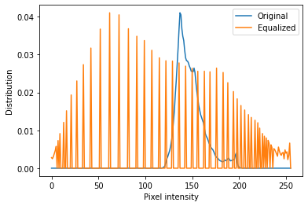

Equalized cumulative histogram
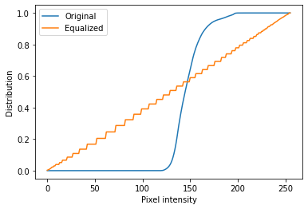

Example image
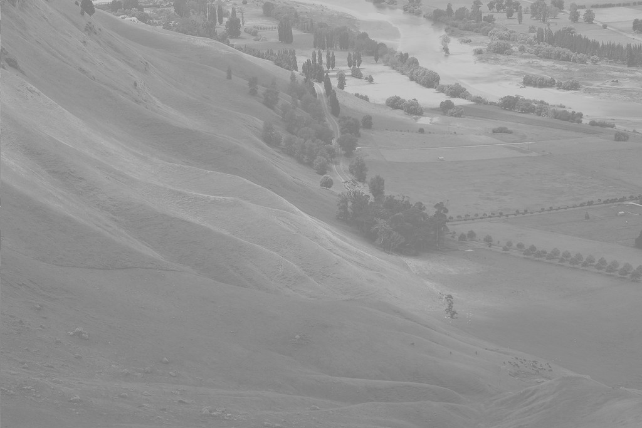

Equalized Image
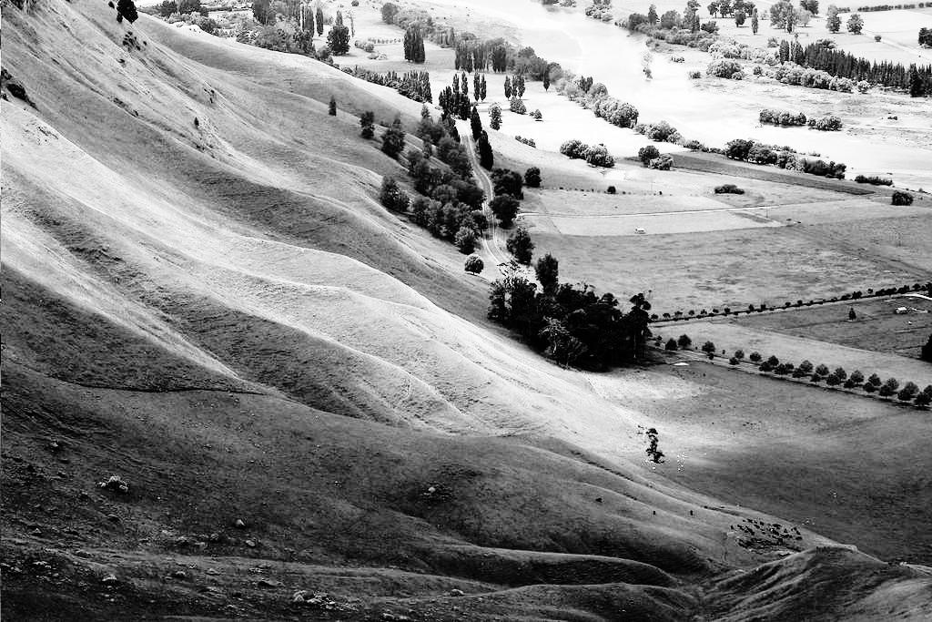

Histogram equalization is a straightforward image-processing technique often used to achieve better quality images in black and white color scales in medical applications such as digital X-rays, MRIs, and CT scans. All these images require high definition and contrast of colors to determine the pathology that is being observed and reach a diagnosis. However, in some type of images histogram equalization can show noise hidden in the image after the processing is done. This is why it is often used with other imaging processing techniques.

References:
- https://en.wikipedia.org/wiki/Adaptive_histogram_equalization#Contrast_Limited_AHE
- https://docs.opencv.org/master/d5/daf/tutorial_py_histogram_equalization.html

